BUSINESS REQUIREMENT DOCUMENT

<<Communication Journey: Live Training Group Session from CRM>>

<<Dhawal Sah>>

<<Aravind Ravi Sankar>>

**VERSION: 1.0**

DATE <<2022-05-24 >>

**TABLE OF CONTENTS**

**1.1 Problem Statement/ Requirement Background** **3**

**1.2 Current Solution/Process (if any)** **3**

**1.3 Related Documents** **3**

**1.4 Solution Scope** **3**

**1.5 Constraints** **3**

**1.6 Business Goals and Objectives** **3**

**1.7 Priority** **3**

**1.8 Target User/ User Community** **3**

**1.9 Impact Analysis** **4**

**1.10 Additional Information** **4**

**1.11 Stakeholder consultation** **4**

**1.12 Approvers** **4**

### 

### 1.1 Problem Statement/ Requirement Background

What are the current problem statements faced by the Business owner?

Currently there are no automated reminder emails sent to the aspirant before the start of the session and during the session. The reminders are sent manually through trainers and Career Coaches before the session. Aspirants not attending the session are not also not being notified.

Provide a brief introduction to the project. This includes describing the business context of the project and the users.

The sessions are scheduled on CRM by the Trainers. But there are no automated reminder mails being sent to the aspirant. Trainers and Career Coaches manually send reminder mails but it contains the G-meet link for the session and not any link which redirects to the app. Attendance of an aspirant is tracked only when he/she joins through the app.

### 1.2 Current Solution/Process (if any)

Describe the current environment as it relates to the solution scope for this document. Does the client have an existing solution? What is it? What are some of its key challenges? What is being done manually?

Currently, Live Sessions is a feature used to schedule Live Group Sessions. The sessions are scheduled by Trainers

Some of its features are:

* ability to schedule sessions for aspirants in a particular (Aspirant Stage)
* displays all the upcoming sessions
* displays the date, and time of the session, trainer for the session, etc.
* ability to edit Session details
* Card appears 24 hours before the session in the respective aspirants app

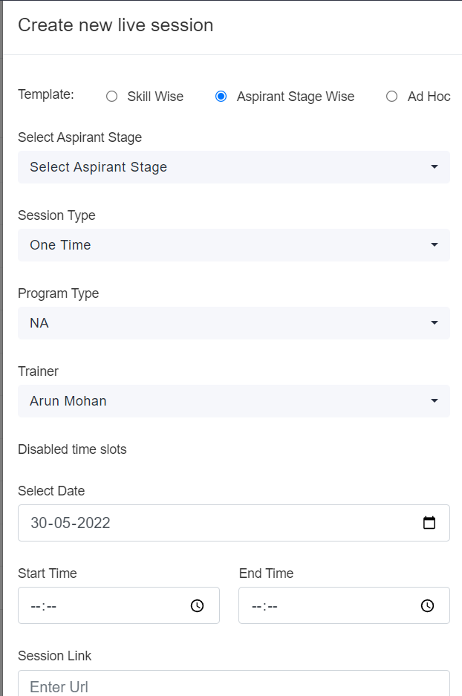

**Schedule Session Feature**

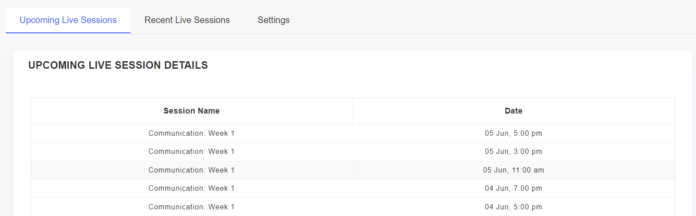

**Upcoming Live Group Sessions - Displays date, time, Session Name**

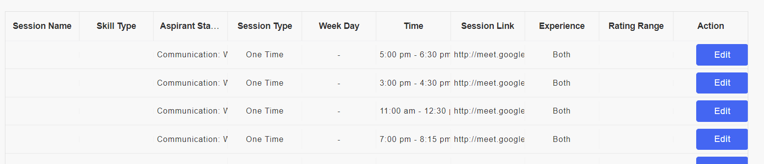

**Ability to Edit Sessions**

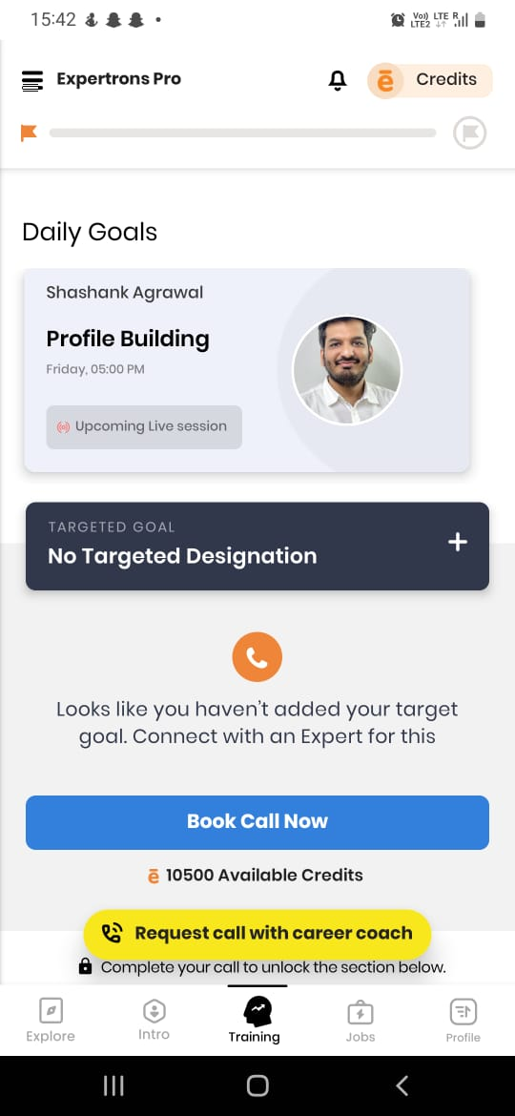

**Card which Appears 24 hours before the session**

Some of the key challenges include:

* Manually Sending of reminder emails before the session starts
* No reminder emails sent to aspirants 10 minutes prior to the start of session
* Aspirant is not notified of his attendance after the session gets over.
* Trainers and Career Coaches are not notified of the tracked attendance in the session
* Aspirants not being redirected to the app to join the sessions

Currently, the following are being done manually

* Reminder aspirants of their session through Calls, telegram messages, mails, etc.
* Sending feedback forms and attendance forms manually to the aspirants

If the current solution has financial impacts, provide a high level description.

### 1.3 Related Documents

Reference any business deliverables / documents associated with this requirements document.

### 1.4 Solution Scope

Define the scope of the solution that this document describes. Indicate any components no longer in scope (e.g., scope changes from that described in the Preliminary Scope document).

Business needs are of an automated Communication Journey for the Live Training Group Session feature having the following components:

* automated mails reminding an aspirant of his sessions 1, 3 and 6 hours before the session start time
* automated mails reminding an aspirant of his sessions, 5 minutes before the Session Start time
* automated mails reminding those aspirants who have not joined the session
* Attendance tracked at specific intervals sent to Trainer and Career Coach at the end of each session
* automated Attendance mails sent to aspirants

Detailed Breakdown of all the features: [Group Sessions - Feature List and Priority](https://docs.google.com/spreadsheets/d/18u_FMIaYaE5mVasvQ0Lo32e4T2bcqJVP_do3KeOTesw/edit#gid=0)

### 1.5 Constraints

What are the business goals and objectives we are trying to achieve with this project

### 1.6 Business Goals and Objectives

What are the business goals and objectives we are trying to achieve with this project

Implementing a Communication Journey to Group Sessions increases the aspirant interaction with the app and the process. It relieves Trainers and Career Coaches’ work of sending reminder mails daily to aspirants, thus increasing their bandwidth and efficiency. Also a dedicated reminder system is developed which would lead to more aspirants joining the session since reminder emails are sent at particular intervals and to the concerned group of aspirants. Also Trainers and Career Coaches are relieved of their manual task of tracking attendance by an automated attendance notifier.

### 1.7 Priority

Use the following three categories to prioritize requirements (do not introduce and mix other prioritization methods such as the MoSCoW method):

* **High** to indicate a solution element that is critical to the client’s business function and operation;
* **Medium** to indicate a non-critical solution element that provides significant benefit to the client; and
* **Low** to indicate a non-critical solution element that provides a helpful or convenient feature that is beneficial to the client.

Detailed Breakdown of all the features: [Group Sessions - Feature List and Priority](https://docs.google.com/spreadsheets/d/18u_FMIaYaE5mVasvQ0Lo32e4T2bcqJVP_do3KeOTesw/edit#gid=0)

### 1.8 Target User/ User Community

If applicable, identify all possible user groups for the solution.

For each user group, estimate the number of users and reference the functional areas each will need access to.

All the aspirants currently involved in the Training phase

All the Trainers and Career Coaches

### 1.9 Impact Analysis

How is this product/feature

### 1.10 Additional Information

Include any information related to the requirement (e.g., hyperlinks to related online content). Where appropriate:

* Reference the associated business process model within the *Business Process Definition* document; and
* Identify the owner (e.g., source) of the requirement.

Communication Journey should include the following:

* Email Content - [Link](https://docs.google.com/spreadsheets/d/18u_FMIaYaE5mVasvQ0Lo32e4T2bcqJVP_do3KeOTesw/edit#gid=0) (Doc links provided in the sheet)
* Flowthrough - [Link](https://docs.google.com/spreadsheets/d/18u_FMIaYaE5mVasvQ0Lo32e4T2bcqJVP_do3KeOTesw/edit#gid=0) (Flowchart Sheet)

**Additional Features:**

There are some additional features which need to be added for the smooth functioning of communication Journey.

1. Session Card going Live 5 minutes before the Session Start Time. This would ensure that aspirants are joining the session before the start time and not after the session starts
2. Automatic Google Meet link generation for Scheduling of Group Sessions. This feature is currently available for 1:1 Live Sessions.

### 1.11 Stakeholder consultation

Identify the stakeholders for the solution and for the project, what their role(s) are, and whether they were consulted.

| **Stakeholder Name** | **Role** | **Consulted** |
| --- | --- | --- |
| Anjali Raul | Assisted in understanding the “Scheduling of Group Sessions” feature on CRM | Yes |
| Siddarth Nautiyal | Conveyed all the CRM features and also assisted me in understanding the Communication Journey | Yes |
| Aravind Ravi Sankar | Reviewed all the Communication Journeys and all the use cases | Yes |
| Sonal Batra | Reviewed the Communication Journeys and suggested changes regarding trigger time of communications | Yes |

### 1.12 Approvers

The following individuals have approved the financial requirements on the date indicated.

| **Approver Name** | **Role** | **Approved** |
| --- | --- | --- |
|  |  | << Yes / No >> |
|  |  | << Yes / No >> |
|  |  | << Yes / No >> |